**Company Name:** BlackRock Engineering and Construction Consulting LLC..

**Address:** **2000 PGA BVD, Palm Beach Gardens, Suit 4440 FL 33408**

**Phone Number**: 561.418.2420

**Email Address**: [Sandynr@blackrockoilgas.com](mailto:Sandynr@blackrockoilgas.com)

**Website**: www.blackrockoilgas.com

**DUNS Number**: 11-766-5081

**Cage Code**: 8GJU4

**BlackRock Engineering and Construction Consulting LLC.**



**CAPABILITY STATEMENT**

**COMPANY OVERVIEW**

**PAST DISASTERS**

We are a staffing consulting company that seeks to provide disaster relief services in the form of technical assistance to the US DHS Federal Emergency Agency (FEMA) and Combines with over 30 years of experience working with applicants at State and local governments in collaborating to help before, during and after a disaster.

* DR4437FL
* DR4339PR
* DR4277LA
* DR1607
* DR4263
* DR4458LA
* DR4337FL
* DR1603
* DR4339PR
* DR4277

**EXPECTED PERFORMANCE**

On the ground performing FEMA designated site visits and damage assessments of disaster-related damaged infrastructure. Working with the state and local governments in collaboration to develop Grants Manger deliverables including Damage Description Documents (DDD), Scopes of work (SOW) and Cost estimates (CEF), for restoration of damaged infrastructure and for cost effective hazard mitigation measures. This work will involve working with the State and local governments to come to agreement on damage descriptions, scopes of work, and a cost estimate. Providing superior technical support and guidance on assessing damaged facilities, creating project work and grant formulation for delivery of the program to applicants including project closeout.

**CORE COMPETENCIES**

**www.BackRockoilgas.com**

**NAICS CODE**

41219, 213112, 541310, 541513, 561330, 561320, 541330, 541310, 237120, 562119, 562910.

**PARTNERS**







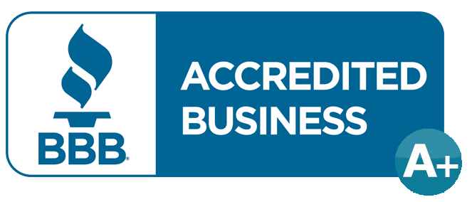











**561.418.2420**

**DIFFERENTIATOR**

**Professional Registration:**

* PE # A1018106, Texas, Florida
* APEGA PE # 45154
* PMP/PMI # 5761699

Contract Staffing:

* Project Managers
* Program Delivery Manager
* Civil, Mechanical & Structural Engineers
* Architects
* Environmental Specialist
* Insurance Specialist
* Construction Managers
* Policy & Supervisors Professionals

**2000 PGA BVD, Palm Beach Gardens, Suit 4440 FL 33408**